Case Study: A Brief Analysis of the Astrological Tripod of Life: The Sun, The Moon and The Ascendent
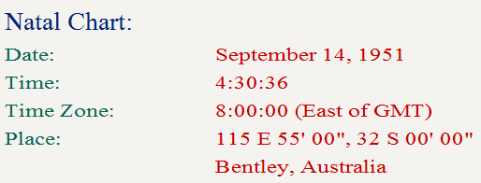
We are moving around
the zodiac
in this direction
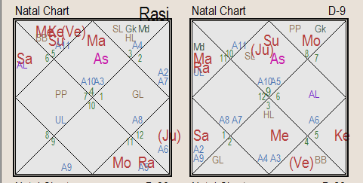
constellationn
Ascendant

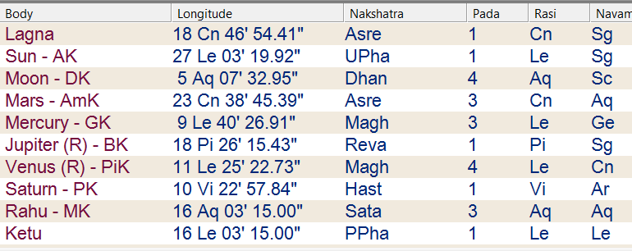
ascendant

Cancer is the sign rising at birth, with the youthful fiery warrior planet Mars also on the horizon at the time of birth and this would suggest a person who has strong emotional ties and past lives in military affairs. This person may always be ready for the fight, athletic, well built, fascinated with elements of war and strategy, logistics, upholding justice, and can get highly angered if and when provoked!
Infact this placement of the ascendant indicates someone who would be a formidable enemy and may strike back with a vengeance if and when provoked.

Emotional moon resides in Aquarius in the eighth house along with north node (Rahu) and also indicates a personality that is fascinated with research and has very deep concentration faculty. The person may be unconventional and like to play outside the box. The Moon takes precedence in Vedic astrology: a strong mind can circumvent many obstacles in life, the mind being the seating place of desire. This lunar position in the chart suggests a person who can be very emotionally disciplined. However “there are many straws in ‘ole doodles brain.”

There may be some unusual karmas or ties with the mother and/ or women in general. Or the paternal influence may have been more prominent. The person has a pronounced intuition on things, will be secretive, reserved emotionally and hides emotional content carefully. He may be difficult to get next to emotionally.

The Sun is in Leo alongside 3 other planets – Mercury, Ketu (South Node), and Venus retrograde. Because the sun is flanked with several planets we will take these into brief consideration.
Leo is a fiery masculine and fixed sign signified by the lion – king of the jungle! This loaded second house suggests a person who is articulate and has the gift of the gab, communication being very important to them, highly interested in learning, has strong family ties yet will exert a strong sense of individuality, and with excellent earning capabilities. In fact this chart overall suggests one who is good with money, likes money, counts if carefully, may horde it even (!) will have cash flow, earnings, assets, properties and will win at lotteries, games of speculation or gains through windfalls. He has lady luck on his side and his dreams do come through. A strong personality, he ignites a room when he enters, with a very strong presence, is highly visible in his community or circle of influence. Like a king. This native may be fierce in action, arrogant, self centred, calculated in sexual encounters, choosy in social relationships. The supreme qualities of Leo are its suddenness, aggression and sudden attack.

Another point of interest – the author has noted in charts with Venus retrograde: these people often have a very fastidious nature lurking somewhere. There is something in their nature that insists on high levels of cleanliness, long bathing rituals and/ or peculiar habits in reference to their pattern of personal hygiene. In this case this may also present itself in this person’s food intake (signified by the 2nd house) – they may be finicky or picky in their eating habits and tastes.

Mercury in the second house will also give excellent writing and vocabulary skills and this person could certainly author books. In fact there is a strong emphasis in this chart on second house affairs due to the fact that 4 massive planets sit together in this area (all within 30 degrees) including the Sun. So items that would come into play within the persons experience would include important connection with family, formative and formal education; youth and youthfulness, income, eating habits, upbringing and the things learnt through family in youth; speech and speech patterns. The native will command respect through the messages he conveys Emphasis here is on strong fluid communication skills with two planets (Venus and Mercury within two degrees) in the constellation/asterism of Magha (Magnanimous) which represents a throne. As a matter of detail, one could say royal chamber with a throne. This signifies everything to do with achievement, and the reaping of rewards after the struggle. In the material realm this represents power, respect, authority, and position, all kinds of prestige and worldly honours - in the higher aspect - knowledge of the self. Again Magha constellation has everything to do with ancestors, (prithis) which is the main ruling deity of this star group and the native will be fascinated with all aspects of family heritage and lineage, genes, roots, property, wealth or status through parents or ancestors. He also is the noble protector of his followers.

Added bonus track: Jupiter retrograde in Pisces in the 9th house.
This is a most outstanding feature of this chart and a rare achievement in reference to Vedic astrological doctrines. Jupiter, the Santa Claus of the celestial cabinet, sits in the best house of the chart - the ninth house, retrograde, which reinforces its benevolence.
This would indicate a person who gains tremendously as he matures and evolves. He has good luck in the affairs of performing his duties. He will always end up on top no matter the obstacle. Luck in legal earnings and all matters in regards to law, education – he may partner with a teacher or facilitator. He may have be a lawyer as a vocation except that this clean placement of Jupiter is too kind for it. A Judge may be more in order. In fact the native is an excellent teacher. In Vedic Astrology Jupiter is considered as the noble preceptor of the demi-gods known as Guru or One who is heavy with knowledge! So this may also account for this persons excellent teaching and facilitation skills.
(BTW - Venus is the preceptor of the demons, naturally, with all that, sex, booze and unrestricted enjoyment going on!!)
Another item of interest is that this person has a very good father with strong ethic and moral values. Still, even though the father is good, he may have been somehow distant or unavailable to the native perhaps due to circumstance or cultural penchant. This may tie over into this person’s subtle psyche. The father may have been very conventional or even stern.
So although the native may have had exposure to excellent mentors and teachers including his father, he may at times find that he rebels authority and figure heads. He will certainly have the analytical prowess to cross examine and question authority figures. He will not be a push over in this regard.
The native gains even in the face of litigation and setback. He will gain through inheritance. His life is blessed and he prospers proportionately as he matures. He is loyal, fair and commendable in his point of view and actions. His life is celebrated and he has an excellent destiny. In fact this placement nullifies many negative attributes that may have otherwise surfaced in the character. These are some of the exquisite benefits of Jupiter’s powerful placement here.

In Summary
This analysis is the entry level of what a Jyotishi (Vedic astrologer) would consider in a consultation. We have only touched on a few of the planets and not done any predictions or even spoken much about weaknesses, health issues, vocation, children, timing of events or other details. First we confirm that the information is accurate, research all permutations and possibilities of the planetary configurations and then go into predictions. Vedic astrology prides itself in its predictive accuracy. In short, this chart is graced with long life and success in undertakings through perseverance and even luck.

